UNIVERSITY OF SCIENCE AND TECHNOLOGY OF HANOI

MASTER ICT

MI1.07 –SOFTWARE DEVELOPMENT PROJECT

|  |  |
| --- | --- |
| Huy-Duc LE  University of Science and Technology of Hanoi  Hanoi, Vietnam  lehuyduc3@gmail.com | Vinh-Nam HUYNH  University of Science and Technology of Hanoi  Hanoi, Vietnam  protossnamjune2nd@gmail.com |
|  |  |
| Duc-Quyen NGUYEN  University of Science and Technology of Hanoi  Hanoi, Vietnam  hakonaryuuji@gmail.com | Vu-Hung NGUYEN  University of Science and Technology of Hanoi  Hanoi, Vietnam  hungnga25197@gmail.com |

March 2020

GROUP PROJECT – REPORT

Project REDUCE Manual

The aim of this documentation is to deliver instructions to the user of our Software Development Project – the REDUCE algorithm.

**Table of Contents**

Chapter 1 Software Overview 3

1.1 Goals 3

1.2 Constraints 3

Chapter 2 Software Manual 4

2.1 Graphical User Interface 4

2.2 Detail features 5

# **Chapter 1**

# **Software Overview**

## **1.1 Goals**

Reduce is a parallel design pattern that consists of compute a value from a set of values. One big problem here is linked to the floating point representation of real numbers. Indeed, it is well-known that the sum of several floats is rarely correct!

**For example:** Consider 2 arrays of float number

A = {1.000000000, 2.000000000, 3.000000000},

B = {3.000000000, 2.000000000, 1.000000000}.

Let’s take sum of all elements inside each array. We may obtain res_A = 6.000000001 and res_B = 5.999999999. These 2 results are not exactly the same!

In order to retrieve a “good” approximation of the result, many algorithms may be proposed.

The goal of this project is to compare some of those algorithms, in quality and complexity, respectively.

## **1.2 Constraints**

* The project must be written in C++ and Qt.
* The user should be able to access saved-experiments-result files.

# **Chapter 2**

# **Software Manual**

## **2.1 Graphical User Interface**

The software GUI contains 3 main regions. They are corresponding to Progress tracking, Main input interface and Output box in succession.

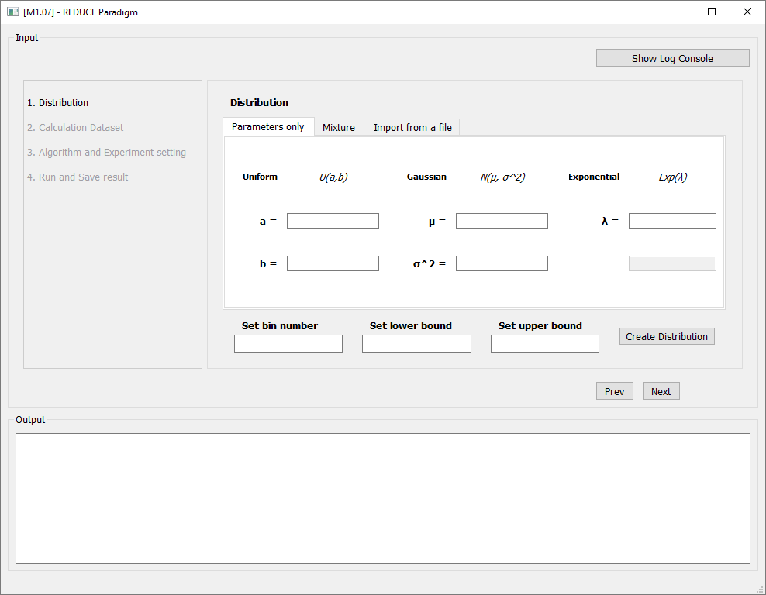

**1.**

**3.**

**2.**

Figure 1: Project GUI – Overview

## **2.2 Detail features**

**Region 1:** Progress tracking

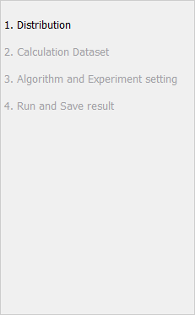

Figure 2: Project GUI – Progress tracking

This region will automatically highlight the current task in the workflow. It ensures that the user know what is going on.

**Region 2:** Main input interface

*Region 2.1: Set Distribution*

**2.** Set Parameters

**1.** Input distribution options

**3.** General distribution settings

**4.** Create distribution

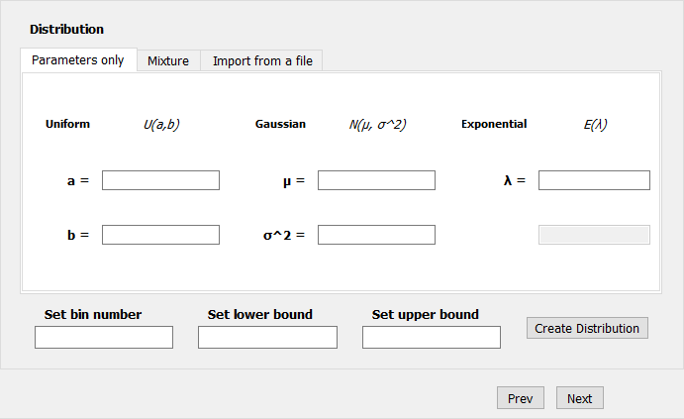

Figure 3: Project GUI – Set Distribution area

- The very first step is to select the most proper input options (see **1.** Input distribution options above). There are 3 ways to setup distribution:

+ Parameters only: The user needs to type in the parameters. The system then parse those parameters to form a distribution.

Choose this option for a distribution such as U(a, b) + N( $μ$, $σ^{2}$) + Exp().

+ Mixture: The user can type in an equation of distribution. The system then parse the string to form a distribution.

Choose this option for a complex mixture of distribution such as

(U(a, b) + N( $μ_{1}$, $σ_{1}^{2}$)) * (N( $μ_{2}$, $σ_{2}^{2}$) + E())

+ Note: only parentheses “(“ and “)” are supported

+ Import from a file: The user can select a text file which contains strings of distribution.

Choose this option to import complex mixture of distributions from a text file such as ((U(a, b) + N( $μ_{1}$, $σ_{1}^{2}$)) * N( $μ_{2}$, $σ_{2}^{2}$)) + E($λ_{1}$) + E()

- After setup distribution, it’s time to establish bin number (the higher bin number, the higher precision), then Lower and Upper bound (measurement range).

- Click Next button to go to the next task.

* **Note: If uniform distribution is used,** then **a**, **b** must be inside **lower bound –> upper bound** range.

*Region 2.2: Set Calculation Dataset*

**4.** Generate dataset

**3.** Get dataset options

**1.** Choose Data Type

**2.** Set Number of data

**6.** Save dataset

**5.** Browse Save Dir

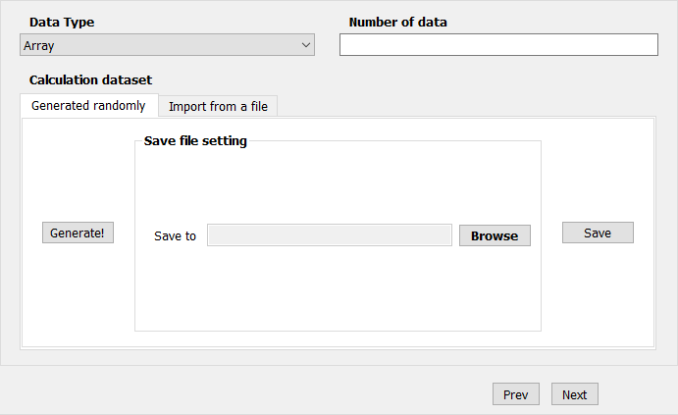

Figure 4: Project GUI – Set Calculation Dataset area

- Click Next button to go to the next task.

- Click Prev button to go to the previous task.

*Region 2.3: Set Experiment setting and Choose Algorithm*

**4.** Set Precision type

**3.** Get dataset options

**1.** Choose Operation

**2.** Set Number of test

**3.** Shuffle/Generate

**5.** Add a current algorithm in **Algorithm List** or Remove one in **Selected Algorithm**

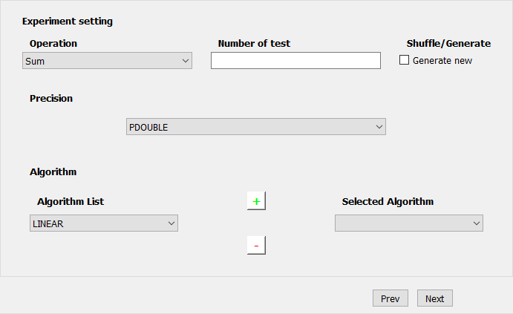

Figure 5: Project GUI – Set Experiment setting and Choose Algorithm area

- Click Next button to go to the next task.

- Click Prev button to go to the previous task.

*Region 2.4: Run and Save Experiment*

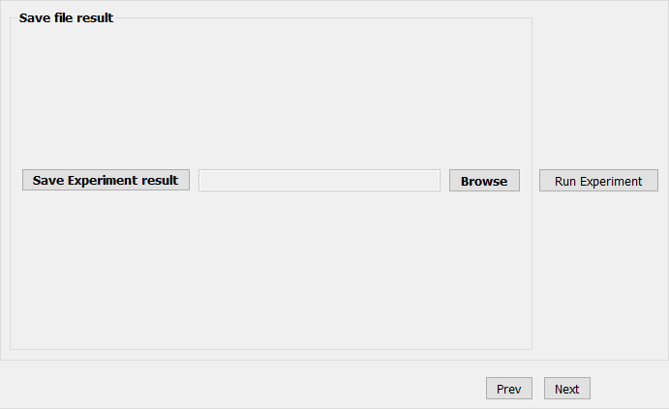

**3.** Save result to the browsed dir

**2.** Browse Save Dir

**1.** Run Experiment

Figure 6: Project GUI – Run and Save Experiment area

- Click Prev button to go to the previous task.

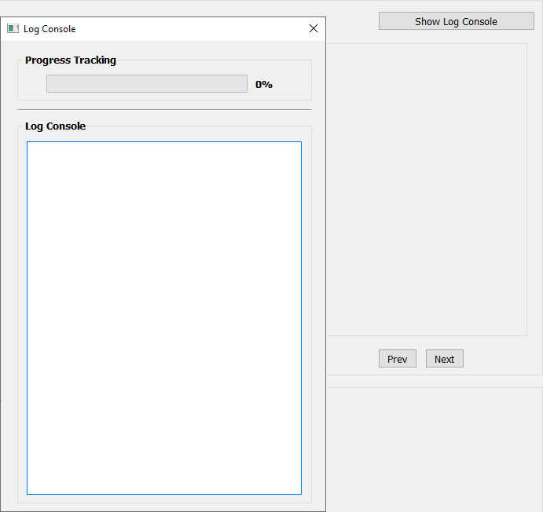

**1.** Show Log Console

**2.** Close Log Console

Figure 7: Project GUI – Show Log Console option

**Region 3:** Output box

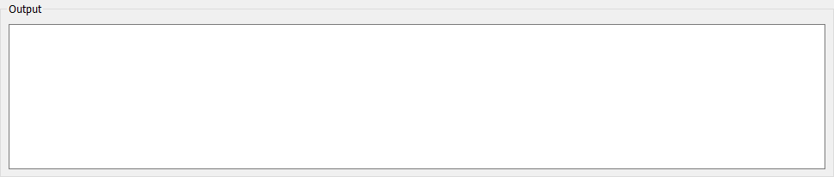

Figure 8: Project GUI – Output box

This region displays the result of the finished experiment(s).